ENTERPRISE DATA BREACH PREVENTION SYSTEM

21CSC205P Database Management Systems
A MINI PROJECT REPORT

Submitted by

SARTHAK RANA [RA2411003010952]
YASH SHARMA [RA2411003010957]

Under the Guidance of

Dr. Aswini Krishnan
Assistant Professor
Department of Computing Technologies, Faculty of Engineering & Technology, Kattankulathur - Chennai

in partial fulfillment of the requirements for the degree of

BACHELOR OF TECHNOLOGY

in


COMPUTER SCIENCE ENGINEERING

DEPARTMENT OF COMPUTING TECHNOLOGIES

SCHOOL OF COMPUTING

COLLEGE OF ENGINEERING AND TECHNOLOGY
SRM INSTITUTE OF SCIENCE AND TECHNOLOGY

KATTANKULATHUR- 603 203

MAY 2026



SRM INSTITUTE OF SCIENCE AND TECHNOLOGY KATTANKULATHUR – 603 203

BONAFIDE CERTIFICATE

Certified that Project report titled “ENTERPRISE DATA BREACH PREVENTION SYSTEM” is the Bonafide work of “SARTHAK RANA [RA2411003010952], YASH SHARMA [RA2411003010957]” who carried out the 21CSC205P Database Management Systems mini project work under my supervision.

COURSE FACULTY  DR. ASWINI KRISHNAN | HEAD OF THE DEPARMENT  DR. G. NIRANJANA
Assistant Professor  Department of Computing Technologies, Faculty of Engineering & Technology, Kattankulathur - Chennai | Professor And Head  Department of Computing Technologies, Faculty of Engineering & Technology, Kattankulathur - Chennai

ABSTRACT

In modern enterprises, large volumes of sensitive organizational and employee data are accessed daily through multiple interconnected systems. This increased dependency on digital systems has also increased the risk of data breaches, particularly due to insider threats and unauthorized access. Traditional logging systems record access activities but lack structured analysis and proactive detection mechanisms. The Enterprise Data Breach Prevention System is designed to address this challenge using Database Management System (DBMS) concepts. The system maintains a centralized database to record employee access activities, monitor interactions with enterprise systems and data assets, calculate risk scores, and generate alerts for suspicious behaviour. By modelling the system using ER diagrams and implementing it through relational schemas, the project ensures data integrity, accurate relationship mapping, and efficient analysis. This system provides a structured and scalable approach to early detection and prevention of potential data breaches in enterprise environments.

TABLE OF CONTENTS

Chapter No. | Title | Page no.
 | ABSTRACT | 3
1 | Problem understanding, Identification of Entity and Relationships, Construction of DB using ER Model for their project | 7
2 | Design of Relational Schemas, Creation of Database and Tables for their project | 12
3 | 3.1Writing queries based on the concepts of Aggregate functions, constraints, sets | 19
 | 3.2 Writing complex queries based on subqueries, joins and views | 23
 | 3.3 Writing complex queries based on the concepts of functions, Triggers, Cursors and Exception Handling | 29
4 | 4.1 Analysing the pitfalls, identifying the dependencies, and applying Normalizations- 1NF, 2NF, 3NF
 | 4.2 Analysing the pitfalls, identifying the dependencies, and applying Normalizations- 4NF, 5NF
5 | Implementation of concurrency control and recovery mechanisms.
6 | Front-end And Back-End Implementation code
7 | Results and Discussions

LIST OF FIGURES

Figure No. | Name | Page no.
1 | ER diagram of Enterprise Data Breach Prevention System | 10
2 | Relational Schema for Enterprise Data Breach Prevention System | 12
3
4
5

LIST OF TABLES

Figure No. | Name | Page no.
1 | Table 2.1: EMPLOYEE | 13
2 | Table 2.2: SYSTEM_INFO | 13
3 | Table 2.3: DATA_ASSET | 14
4 | Table 2.4: ACCESS_LOG | 14
5 | Table 2.5: RISK_SCORE | 15
6 | Table 2.6: ALERT | 15

CHAPTER 1

PROBLEM UNDERSTANDING, IDENTIFICATION OF ENTITY AND RELATIONSHIPS, CONSTRUCTION OF DB USING ER MODEL FOR THE ENTERPRISE DATA BREACH PREVENTION SYSTEM

  - Introduction

In today’s digital era, enterprises rely heavily on information systems to manage critical business operations and store sensitive data such as employee records, client information, and financial data. Employees interact with multiple enterprise systems on a daily basis, generating large volumes of access-related data. While this digital transformation improves efficiency, it also introduces significant security risks, particularly in the form of insider threats and unauthorized data access.

Data breaches can lead to severe financial losses, legal consequences, and reputational damage for organizations. Many existing systems focus only on access control and logging mechanisms, which are insufficient for identifying suspicious behavior in real time. Hence, there is a need for a structured database-driven solution that not only stores access information but also enables analysis and monitoring of access patterns.

The Enterprise Data Breach Prevention System is a DBMS-based solution that models enterprise access activities using entities, relationships, and constraints. It provides a centralized platform to store access logs, evaluate employee risk levels, and generate alerts, thereby enabling early detection and prevention of potential data breaches.

  - Motivation

- Rising Enterprise Data Breaches: Modern enterprises store highly sensitive data across multiple systems. The increase in digital access has significantly raised the risk of internal and external data breaches.
- Insider Threats and Misuse of Access: Authorized employees can unintentionally or maliciously misuse their access privileges. Traditional systems fail to continuously monitor and analyze such behavior.
- Limitations of Traditional Logging Systems: Most organizations only maintain access logs without structured analysis. This makes detection of suspicious activity reactive rather than proactive.
- Application of DBMS Concepts to Real Problems: The project is motivated by the need to apply ER modelling, relational schemas, and SQL queries to solve real-world enterprise security issues.
- Industry Relevance: The system reflects real IT-industry practices, making it useful for large organizations that require structured data monitoring and breach prevention.

  - Scope

- The project focuses on designing a centralized database to store and manage employee access activities within an enterprise.
- It includes monitoring interactions between employees, enterprise systems, and sensitive data assets.
- The system evaluates employee risk levels based on access behaviour and generates alerts for suspicious activities.
- The scope is limited to ER modelling, relational schema design, and SQL-based database implementation.
- Network security, encryption, and real-time intrusion detection mechanisms are outside the scope of this project.

  - Problem Statement

Enterprises handle large volumes of sensitive data accessed by multiple employees across various systems, making them vulnerable to insider threats and unauthorized access. Existing logging mechanisms lack effective analysis and early detection of suspicious behaviour. There is a need for a centralized DBMS-based solution that records access activities, analyses risk patterns, and proactively generates alerts to prevent potential data breaches.

  - Project Requirements

Functional Requirements
- Store employee details
- Store enterprise system information
- Store data asset details
- Record access activities in access logs
- Maintain risk score for each employee
- Generate alerts for suspicious access behaviour

Non-Functional Requirements
- Data integrity using primary and foreign keys
- Scalability for large data volumes
- Consistency and accuracy of stored data
- Secure and structured database design

  - Identification of Entity and Relationships

Entities Identified
- EMPLOYEE
- SYSTEM
- DATA_ASSET
- ACCESS_LOG
- RISK_SCORE
- ALERT

Relationships Identified
- EMPLOYEE generates ACCESS_LOG
- SYSTEM logs ACCESS_LOG
- DATA_ASSET involves ACCESS_LOG
- EMPLOYEE has RISK_SCORE
- EMPLOYEE triggers ALERT
Each relationship is defined with appropriate cardinalities and participation constraints based on real-world enterprise behaviour.

  - Construction of DB Using ER Model for the Enterprise Data Breach Prevention System
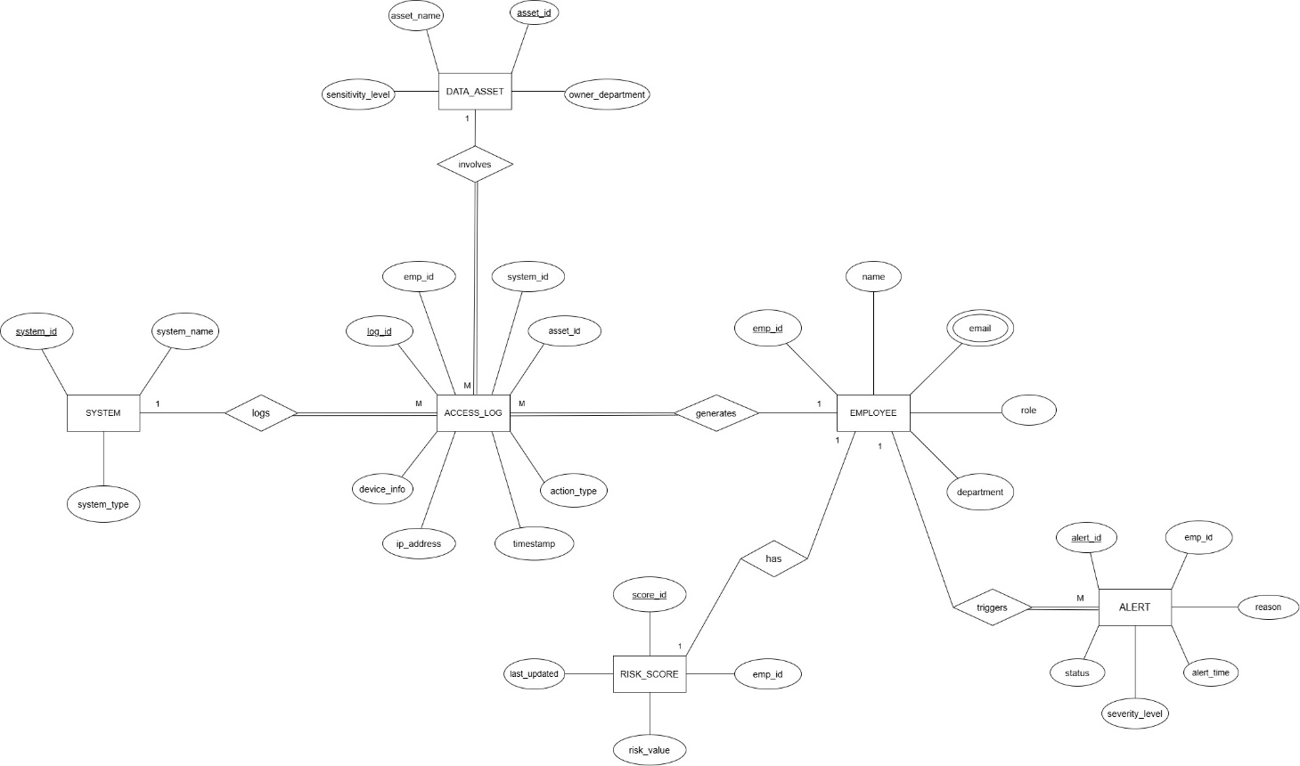
Figure 1.1: ER diagram of Enterprise Data Breach Prevention System

This ER diagram represents the Enterprise Data Breach Prevention System, where employee access to enterprise systems and sensitive data assets is centrally monitored. The core entity ACCESS_LOG acts as an associative entity that records every access event, linking EMPLOYEE, SYSTEM, and DATA_ASSET. Each access log captures details such as action type, timestamp, IP address, and device information, ensuring that every interaction with enterprise data is traceable. The relationships show that one employee, system, or data asset can be associated with many access logs, while each access log must be linked to exactly one employee, one system, and one data asset.
Additionally, the diagram models risk assessment and alert management. Each EMPLOYEE has exactly one RISK_SCORE, representing a one-to-one relationship, indicating continuous evaluation of employee behavior. The ALERT entity captures security warnings generated due to suspicious activities, where one employee can trigger multiple alerts (one-to-many relationship). Overall, the ER diagram clearly defines entities, attributes, cardinalities, and participation constraints to ensure data integrity, effective monitoring, and early detection of potential data breaches within an enterprise environment.

Chapter 2
Design of Relational Schemas, Creation of Database and Tables for Enterprise Data Breach Prevention System

2.1 Relational Schema for Enterprise Data Breach Prevention System
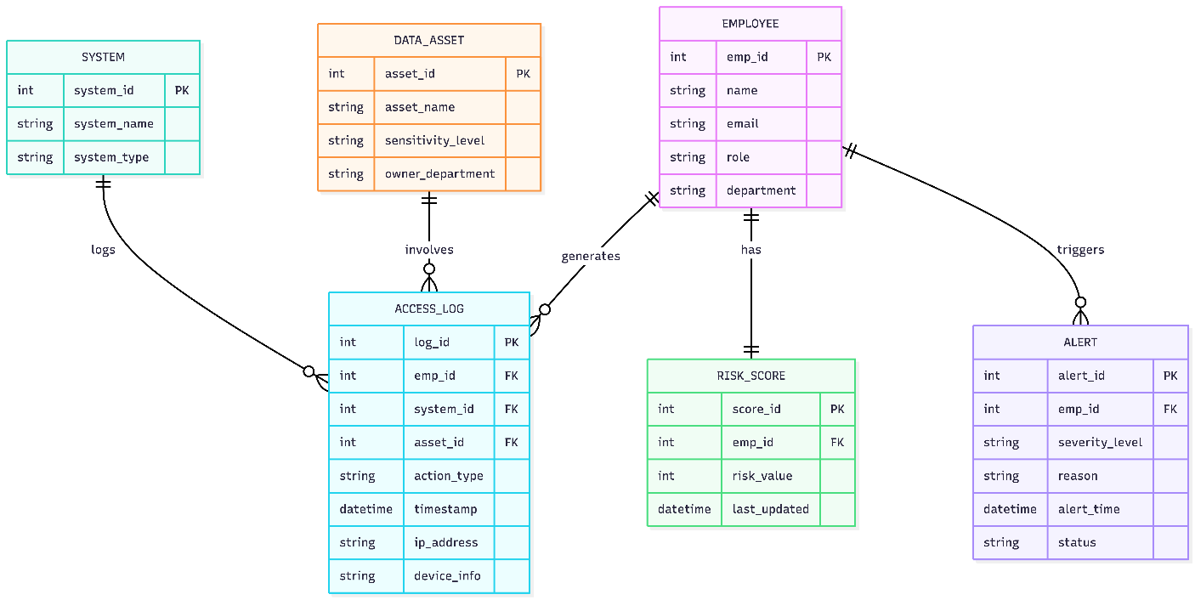
Figure 2.1: Relational Schema for Enterprise Data Breach Prevention System

The figure 2.1 depicts the relational schema for the Enterprise Data Breach Prevention System which represents the database design of the Enterprise Data Breach Prevention System, where enterprise access activities are stored and analyzed in a structured manner. The core tables include EMPLOYEE, SYSTEM, and DATA_ASSET, which store master information about employees, enterprise systems, and sensitive data respectively. The ACCESS_LOG table acts as the central transactional table, capturing every access event with references (foreign keys) to employee, system, and data asset. This ensures that each access is traceable to who accessed what data using which system, along with contextual details such as action type, timestamp, IP address, and device information.
The schema also supports security analysis through RISK_SCORE and ALERT tables. Each employee is associated with exactly one risk score (1:1 relationship), enabling continuous risk evaluation based on access behavior. The ALERT table records security warnings generated due to suspicious activities, where one employee can trigger multiple alerts (1:N relationship). Primary and foreign key constraints enforce referential integrity across all tables, ensuring consistency and accuracy of data. Overall, this relational schema efficiently converts the ER model into a normalized database structure suitable for monitoring, analysis, and prevention of enterprise data breaches.

2.2 Description of Tables
Table 2.1: EMPLOYEE
- Purpose:
Stores details of employees working in the enterprise, including their identity, role, and department information. This table helps in tracking which employee accesses systems and data assets.
- Primary Key: Emp_ID (INTEGER)
- Data Types and Constraints:
- Emp_ID: INTEGER, Primary Key, Not Null
- Name: VARCHAR(50)
- Email: VARCHAR(50)
- Role: VARCHAR(30)
- Department: VARCHAR(30)

Table 2.2: SYSTEM_INFO
- Purpose:
Stores details of enterprise systems through which employees access organizational data. This helps in identifying the system involved in each access activity.
- Primary Key: System_ID (INTEGER)
- Data Types and Constraints:
- System_ID: INTEGER, Primary Key, Not Null
- System_Name: VARCHAR(50)
- System_Type: VARCHAR(30)
Table 2.3: DATA_ASSET
- Purpose:
Stores information about sensitive data assets within the enterprise, including their sensitivity level and owning department. This helps in assessing the criticality of accessed data.
- Primary Key: Asset_ID (INTEGER)
- Data Types and Constraints:
- Asset_ID: INTEGER, Primary Key, Not Null
- Asset_Name: VARCHAR(50)
- Sensitivity_Level: VARCHAR(20)
- Owner_Department: VARCHAR(30)

Table 2.4: ACCESS_LOG
- Purpose:
Stores detailed records of every access activity performed by employees on enterprise systems and data assets. This table acts as the core table for monitoring and analyzing access behavior.
- Primary Key: Log_ID (INTEGER)
- Data Types and Constraints:
- Log_ID: INTEGER, Primary Key, Not Null
- Emp_ID: INTEGER, Foreign Key, References EMPLOYEE(Emp_ID)
- System_ID: INTEGER, Foreign Key, References SYSTEM_INFO(System_ID)
- Asset_ID: INTEGER, Foreign Key, References DATA_ASSET(Asset_ID)
- Action_Type: VARCHAR(20)
- Timestamp: DATETIME
- IP_Address: VARCHAR(20)
- Device_Info: VARCHAR(50)
Table 2.5: RISK_SCORE
- Purpose:
Stores the risk score associated with each employee based on their access behavior. This table helps in identifying employees with potentially risky access patterns.
- Primary Key: Score_ID (INTEGER)
- Data Types and Constraints:
- Score_ID: INTEGER, Primary Key, Not Null
- Emp_ID: INTEGER, Foreign Key, References EMPLOYEE(Emp_ID)
- Risk_Value: INTEGER
- Last_Updated: DATETIME

Table 2.6: ALERT
- Purpose:
Stores alert details generated due to suspicious or abnormal access activities by employees. This table supports early detection and response to potential data breaches.
- Primary Key: Alert_ID (INTEGER)
- Data Types and Constraints:
- Alert_ID: INTEGER, Primary Key, Not Null
- Emp_ID: INTEGER, Foreign Key, References EMPLOYEE(Emp_ID)
- Severity_Level: VARCHAR(20)
- Reason: VARCHAR(100)
- Alert_Time: DATETIME
- Status: VARCHAR(20)

2.3 Creation of Database and Tables - DDL Commands
DDL Commands to create all the tables.
- Database Creation
CREATE DATABASE enterprise_guard;
USE enterprise_guard;
- Creation of EMPLOYEE Table
CREATE TABLE employee (emp_id INT PRIMARY KEY, name VARCHAR (50), email VARCHAR (50), role VARCHAR (30), department VARCHAR (30));
- Creation of SYSTEM_INFO Table
CREATE TABLE system_info (system_id INT PRIMARY KEY, system_name VARCHAR (50), system_type VARCHAR (30));
- Creation of DATA_ASSET Table
CREATE TABLE data_asset (asset_id INT PRIMARY KEY, asset_name VARCHAR (50), sensitivity_level VARCHAR (20), owner_department VARCHAR (30));
- Creation of ACCESS_LOG Table
CREATE TABLE access_log ( log_id INT PRIMARY KEY, emp_id INT, system_id INT, asset_id INT, action_type VARCHAR(20), timestamp DATETIME, ip_address VARCHAR(20), device_info VARCHAR(50), FOREIGN KEY (emp_id) REFERENCES employee(emp_id), FOREIGN KEY (system_id) REFERENCES system_info(system_id), FOREIGN KEY (asset_id) REFERENCES data_asset(asset_id) );
- Creation of RISK_SCORE Table
CREATE TABLE risk_score (score_id INT PRIMARY KEY, emp_id INT, risk_value INT, last_updated DATETIME, FOREIGN KEY (emp_id) REFERENCES employee(emp_id));
- Creation of ALERT Table
CREATE TABLE alert (alert_id INT PRIMARY KEY, emp_id INT, severity_level VARCHAR (20), reason VARCHAR (100), alert_time DATETIME, status VARCHAR (20), FOREIGN KEY (emp_id) REFERENCES employee(emp_id));

2.4 Insertion of tuples into the table – DML commands
Data Manipulation Language (DML) commands are used to insert records into the database tables. The following SQL commands insert sample data into the Fake News Data Management and Analysis System tables to demonstrate the working of the database.
- Insert into EMPLOYEE Table
INSERT INTO employee VALUES (1, 'Rahul Sharma', 'rahul@company.com', 'Developer', 'IT'), (2, 'Anita Verma', 'anita@company.com', 'Security Admin', 'Security'), (3, 'Karan Patel', 'karan@company.com', 'Analyst', 'Finance');
emp_id | name | email | role | department
1 | Rahul Sharma | rahul@company.com | Developer | IT
2 | Anita Verma | anita@company.com | Security admin | Security
3 | Karan Patel | karan@company.com | Analyst | Finance

- Insert into SYSTEM_INFO Table
INSERT INTO system_info VALUES (101, 'HRMS', 'Web Application'), (102, 'CRM', 'Web Application'), (103, 'Finance_DB', 'Database');

System_id | System_name | System_type
101 | HRMS | Web Application
102 | CRM | Web Application
103 | Finance_DB | Database

- Insert into DATA_ASSET Table
INSERT INTO data_asset VALUES (201, 'Employee Records', 'High', 'HR'), (202, 'Client Information', 'High', 'Sales'), (203, 'Financial Reports', 'Medium', 'Finance');
Asset_id | Asset_name | Sensitivity_level | Owner_department
201 | Employee Records | High | HR
202 | Client information | High | Sales
203 | Financial Reports | Medium | Finance

- Insert into ACCESS_LOG Table
INSERT INTO access_log VALUES (1001, 1, 101, 201, 'READ', NOW(), '192.168.1.10', 'Laptop'), (1002, 2, 102, 202, 'DOWNLOAD', NOW(), '192.168.1.12', 'Desktop'), (1003, 3, 103, 203, 'READ', NOW(), '192.168.1.15', 'Office-PC'), (1004, 2, 103, 203, 'DOWNLOAD', NOW(), '192.168.1.12', 'Desktop');
log_id | emp_id | System_id | Asset_id | Action_type | timestamp | ip_address | Device_info
1001 | 1 | 101 | 201 | READ | NOW() | 192.168.1.10 | Laptop
1002 | 2 | 102 | 202 | DOWNLOAD | NOW() | 192.168.1.12 | Desktop
1003 | 3 | 103 | 203 | READ | NOW() | 192.168.1.15 | Ofiice-PC
1004 | 2 | 103 | 203 | DOWNLOAD | NOW() | 192.168.1.12 | Desktop

- Insert into RISK_SCORE Table
INSERT INTO risk_score VALUES (1, 1, 30, NOW()), (2, 2, 75, NOW()), (3, 3, 40, NOW());
Score_id | Emp_id | Risk_value | Last_updated
1 | 1 | 30 | 2026-02-10 18:31:56
2 | 2 | 75 | 2026-02-10 18:31:56
3 | 3 | 40 | 2026-02-10 18:31:56

- Insert into ALERT Table
INSERT INTO alert VALUES (1, 2, 'High', 'Multiple sensitive data downloads', NOW(), 'Open'), (2, 3, 'Medium', 'Unusual access timing', NOW(), 'Resolved');
Alert_id | Emp_id | Severity_level | reason | Alert_time | Status
1 | 2 | High | Multiple sensitive data downloads | 2026-02-10 18:34:48 | Open
2 | 3 | Medium | Unusual access timing | 2026-02-10 18:34:48 | Resolved

CHAPTER 3
Complex queries based on the concepts of constraints, sets, joins, views, Triggers and Cursors.

  - Writing queries based on the concepts of Aggregate functions, constraints, sets

    - Adding Constraints and queries based on constraints
  - Question: How to ensure risk value is between 0 and 100?

SQL Statement: ALTER TABLE risk_score
ADD CONSTRAINT chk_risk_range
CHECK (risk_value BETWEEN 0 AND 100);

Output: Query OK, 5 rows affected (0.18 sec)
Records: 5 Duplicates: 0 Warnings: 0 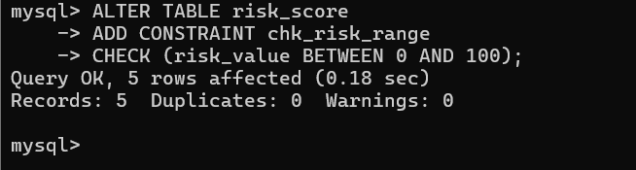

  - Question: How to prevent duplicate email addresses in employee table?

SQL Statement: ALTER TABLE employee
ADD CONSTRAINT unique_email UNIQUE (email);

Output: Query OK, 0 rows affected (0.13 sec)
Records: 0 Duplicates: 0 Warnings: 0
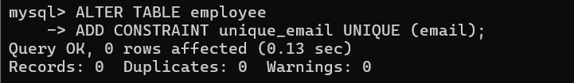

  - Question: How to ensure asset sensitivity is only High, Medium, or Low?

SQL Statement: ALTER TABLE data_asset
ADD CONSTRAINT chk_sensitivity
CHECK (sensitivity_level IN ('High', 'Medium', 'Low'));

Output: Query OK, 3 rows affected (0.08 sec)
Records: 3 Duplicates: 0 Warnings: 0
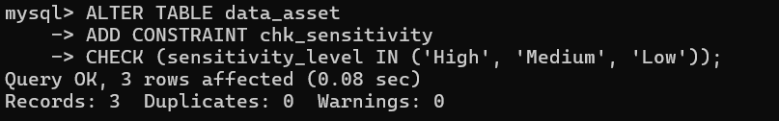

    - Queries based on Aggregate Functions
  - Question: What is the average risk score in the enterprise?

SQL Statement: SELECT ROUND(AVG(risk_value), 2) AS avg_risk_score FROM risk_score;

Output:
Avg_risk_score
43.00
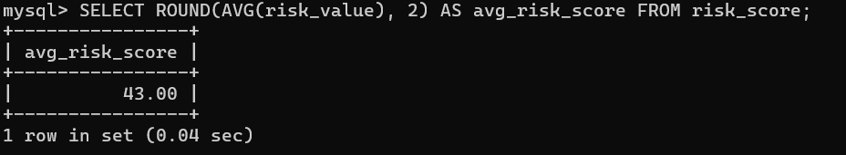

  - Question: How many access logs were generated by each employee?

SQL Statement: SELECT e.emp_id, e.name, COUNT(a.log_id) AS total_logs
FROM employee e
LEFT JOIN access_log a ON a.emp_id = e.emp_id
GROUP BY e.emp_id, e.name
ORDER BY total_logs DESC;

Output:
Emp_id | name | Total_logs
2 | Anita Verma | 4
1 | Rahul Sharma | 1
3 | Karan Patel | 1
4 | Priya Nair | 1
5 | Vikram Singh | 1
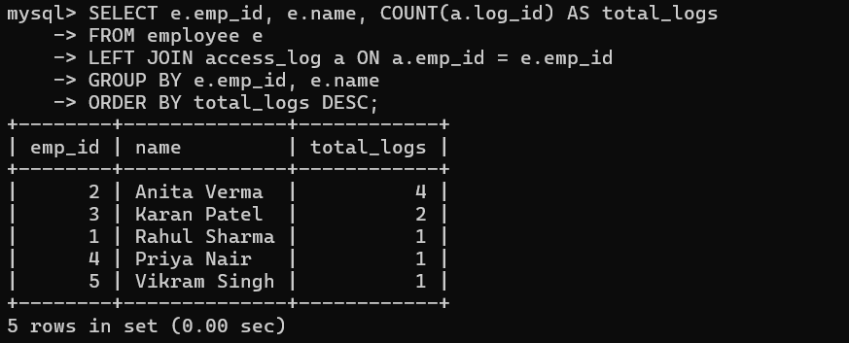

  - Question: What is the maximum and minimum risk score by department?

SQL Statement: SELECT e.department,
MIN(r.risk_value) AS min_risk,
MAX(r.risk_value) AS max_risk
FROM risk_score r
JOIN employee e ON e.emp_id = r.emp_id
GROUP BY e.department;

Output:
Department | Min_risk | Max_risk
IT | 30 | 50
Security | 75 | 75
Finance | 40 | 40
HR | 20 | 20
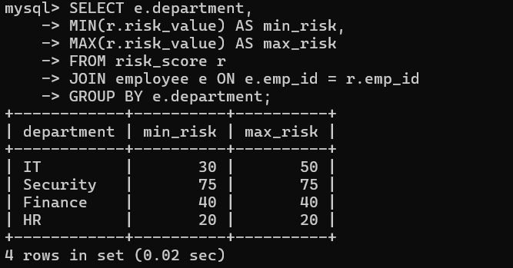

    - Complex queries based on Sets
  - Question: Which employees either have high risk (>=70) OR open alerts?

SQL Statement: SELECT e.emp_id, e.name
FROM employee e
JOIN risk_score r ON r.emp_id = e.emp_id
WHERE r.risk_value >= 70
UNION
SELECT e.emp_id, e.name
FROM employee e
JOIN alert al ON al.emp_id = e.emp_id
WHERE al.status = 'Open';
Output:
Emp_id | Name
2 | Anita Verma
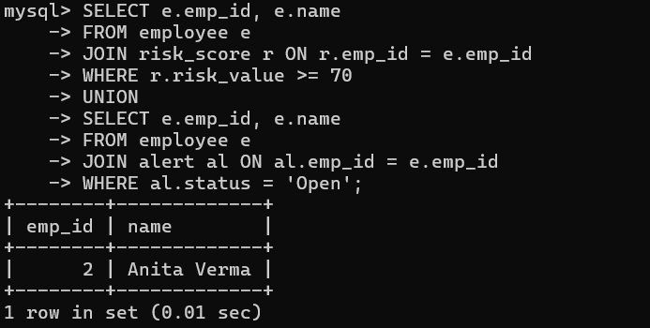

  - Question: Which employees appear in both risky and alerted sets?

SQL Statement: SELECT e.emp_id, e.name
FROM employee e
JOIN risk_score r ON r.emp_id = e.emp_id
WHERE r.risk_value >= 70
AND EXISTS (
SELECT 1
FROM alert al
WHERE al.emp_id = e.emp_id
);

Output:
Emp_id | Name
2 | Anita Verma
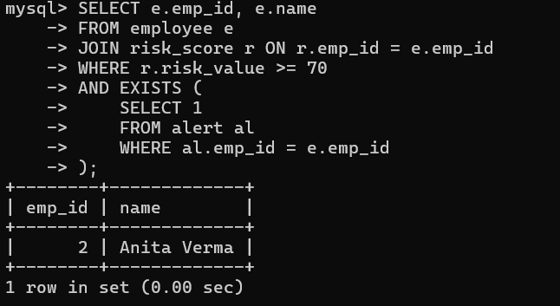

  - Question: Which employees have risk scores but no alerts yet?

SQL Statement: SELECT e.emp_id, e.name
FROM employee e
JOIN risk_score r ON r.emp_id = e.emp_id
WHERE NOT EXISTS (
SELECT 1 FROM alert al WHERE al.emp_id = e.emp_id
);
Output:
Emp_id | name
1 | Rahul Sharma
4 | Priya Nair
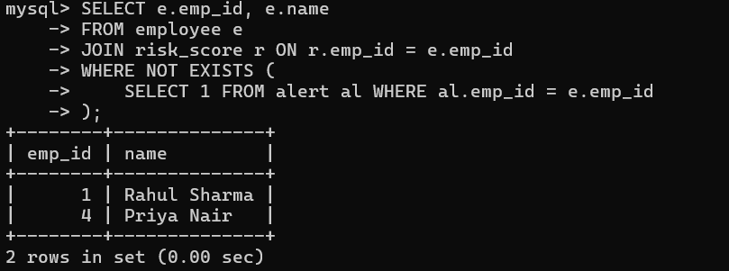

  - Writing complex queries based on subqueries, joins and views

    - Complex queries based on Subqueries
  - Question: Which employees have risk score above enterprise average?

SQL Statement:
SELECT e.emp_id, e.name, r.risk_value
FROM employee e
JOIN risk_score r ON r.emp_id = e.emp_id
WHERE r.risk_value > (SELECT AVG(risk_value) FROM risk_score)
ORDER BY r.risk_value DESC;

Output:
Emp_id | name | Risk_value
2 | Anita Verma | 75
5 | Vikram Singh | 50
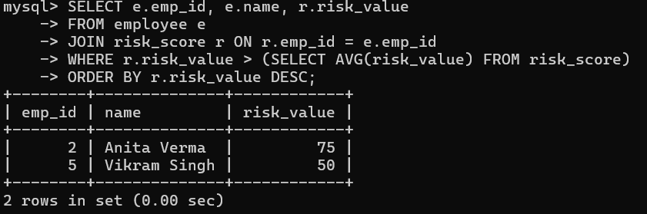

  - Question: Which access logs involve assets with max sensitivity (High)?

SQL Statement:
SELECT *
FROM access_log
WHERE asset_id IN (
SELECT asset_id
FROM data_asset
WHERE sensitivity_level = 'High'
);

Output:
Log_id | Emp_id | System_id | Asset_id | Action_type | timestamp | Ip_address | Device_info
1001 | 1 | 101 | 201 | READ | 2026-03-18 21:21:01 | 192.168.1.10 | Laptop
1006 | 4 | 101 | 201 | READ | 2026-03-18 22:05:01 | 192.168.1.25 | Desktop
1002 | 2 | 102 | 202 | DOWNLOAD | 2026-03-18 21:21:01 | 192.168.1.12 | Desktop
1008 | 2 | 102 | 202 | READ | 2026-03-18 23:13:12 | 192.168.1.50 | Laptop
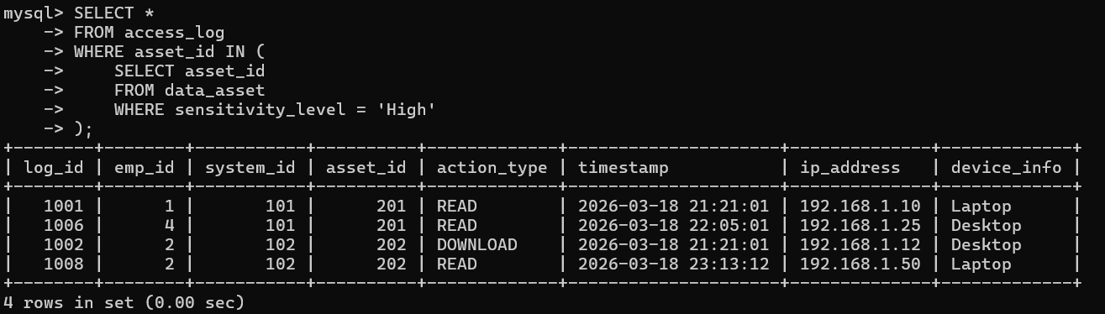

  - Question: Which employees performed more than the average number of accesses?

SQL Statement:
SELECT e.emp_id, e.name, COUNT(a.log_id) AS access_count
FROM employee e
JOIN access_log a ON a.emp_id = e.emp_id
GROUP BY e.emp_id, e.name
HAVING COUNT(a.log_id) > (
SELECT AVG(emp_access_count)
FROM (
SELECT COUNT(*) AS emp_access_count
FROM access_log
GROUP BY emp_id
) t
);

Output:
Emp_id | name | Access_count
2 | Anita Verma | 3
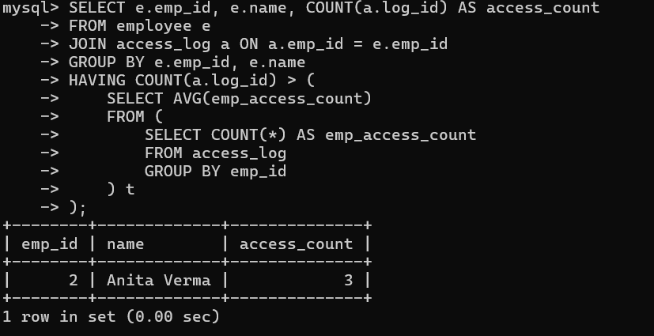

    - Complex queries based on Joins
  - Question: Show complete access trail with employee, system and asset details.

SQL Statement:
SELECT a.log_id, e.name, s.system_name, d.asset_name,
d.sensitivity_level, a.action_type, a.timestamp
FROM access_log a
JOIN employee e ON e.emp_id = a.emp_id
JOIN system_info s ON s.system_id = a.system_id
JOIN data_asset d ON d.asset_id = a.asset_id
ORDER BY a.timestamp DESC;

Output:
Log_id | name | System_name | Asset_name | Sensitivity_level | Action_type | timestamp
1008 | Anita Verma | CRM | Client Information | High | READ | 2026-03-18 23:13:12
1006 | Priya Nair | HRMS | Employee Records | High | READ | 2026-03-18 22:05:01
1005 | Vikram Singh | Finance_DB | Financial Reports | Medium | UPDATE | 2026-03-18 22:05:01
1001 | Rahul Sharma | HRMS | Employee Records | High | READ | 2026-03-18 21:21:01
1002 | Anita Verma | CRM | Client Information | High | DOWNLOAD | 2026-03-18 21:21:01
1004 | Anita Verma | Finance_DB | Financial Reports | Medium | DOWNLOAD | 2026-03-18 21:21:01
1003 | Karan Patel | Finance_DB | Financial Reports | Medium | READ | 2026-03-18 21:21:01
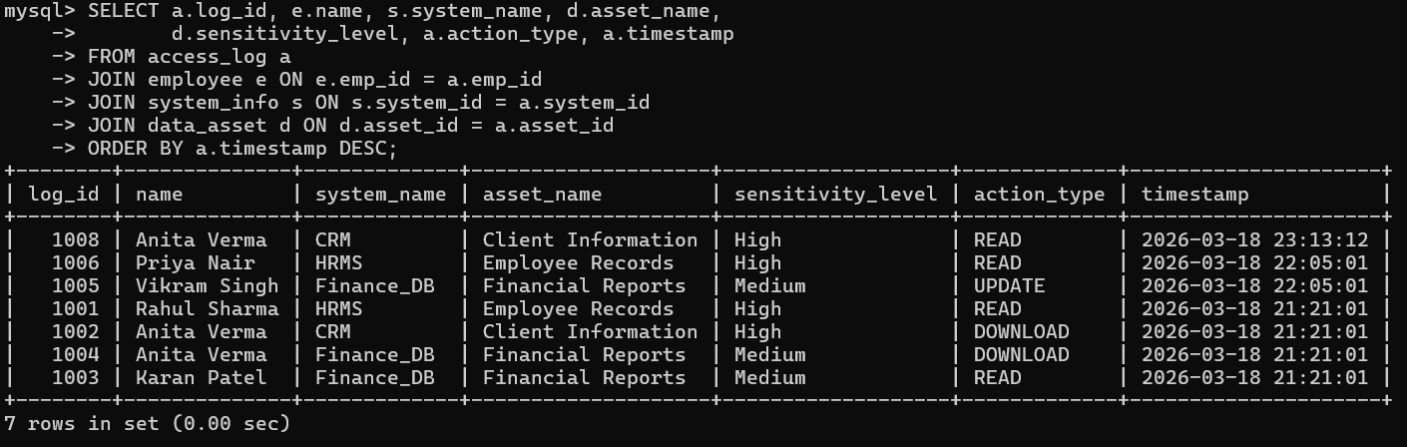

  - Question: Show each employee with risk score and latest alert (if any).

SQL Statement:
SELECT e.emp_id, e.name, r.risk_value, al.severity_level, al.reason, al.status
FROM employee e
JOIN risk_score r ON r.emp_id = e.emp_id
LEFT JOIN alert al ON al.emp_id = e.emp_id;

Output:
Emp_id | name | Risk_value | Severity_level | reason | Status
1 | Rahul Sharma | 30 | NULL | NULL | NULL
2 | Anita Verma | 75 | High | Multiple sensitive data downloads | Open
3 | Karan Patel | 40 | Medium | Unusual access timing | Resolved
4 | Priya Nair | 20 | NULL | NULL | NULL
5 | Vikram Singh | 50 | Low | Frequent system updates | Investigating
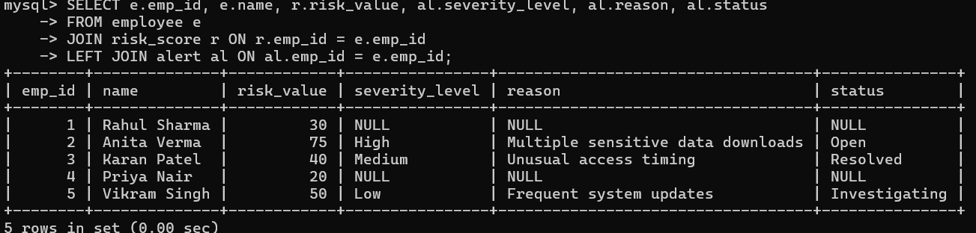

  - Question: Find high-sensitivity asset access done through database systems.

SQL Statement:
SELECT e.name, s.system_name, d.asset_name, d.sensitivity_level, a.action_type
FROM access_log a
JOIN employee e ON e.emp_id = a.emp_id
JOIN system_info s ON s.system_id = a.system_id
JOIN data_asset d ON d.asset_id = a.asset_id
WHERE s.system_type = 'Database'
AND d.sensitivity_level IN ('High', 'Critical');

Output: Empty Set
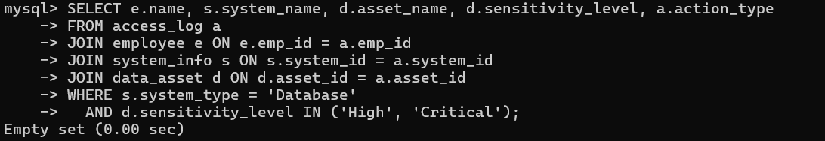
    - Complex queries based on views
  - Question: Create a view for high-risk employees.

SQL Statement:
CREATE VIEW vw_high_risk_employees AS
SELECT e.emp_id, e.name, e.department, r.risk_value
FROM employee e
JOIN risk_score r ON e.emp_id = r.emp_id
WHERE r.risk_value >= 70;

SELECT * FROM vw_high_risk_employees;

Output:
Emp_id | name | department | Risk_value
2 | Anita Verma | Security | 75
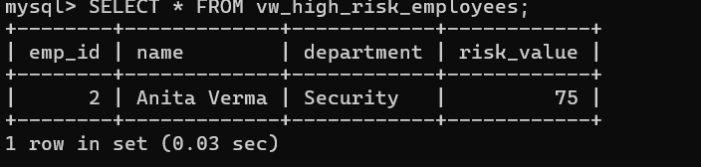

  - Question: Create a view for open alerts with employee details.

SQL Statement:
CREATE VIEW vw_open_alerts AS
SELECT al.alert_id, e.name AS employee_name, al.severity_level, al.reason
FROM alert al
JOIN employee e ON e.emp_id = al.emp_id
WHERE al.status = 'Open';

SELECT * FROM vw_open_alerts;

Output:
Alert_id | Employee_name | Severity_level | reason
1 | Anita Verma | High | Multiple sensitive data downloads
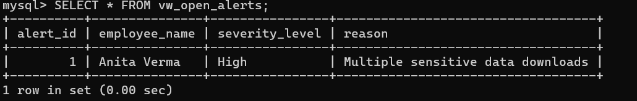

  - Question: Create a view to show employee access details with system name

SQL Statement:
CREATE VIEW vw_employee_access AS
SELECT e.emp_id, e.name, s.system_name, a.action_type
FROM employee e
JOIN access_log a ON e.emp_id = a.emp_id
JOIN system_info s ON a.system_id = s.system_id;

SELECT * FROM vw_employee_access;

Output:
Emp_id | name | System_name | Action_type
1 | Rahul Sharma | HRMS | READ
4 | Priya Nair | HRMS | READ
2 | Anita Verma | CRM | DOWNLOAD
2 | Anita Verma | CRM | READ
3 | Karan Patel | Finance_DB | READ
2 | Anita Verma | Finance_DB | DOWNLOAD
5 | Vikram Singh | Finance_DB | UPDATE
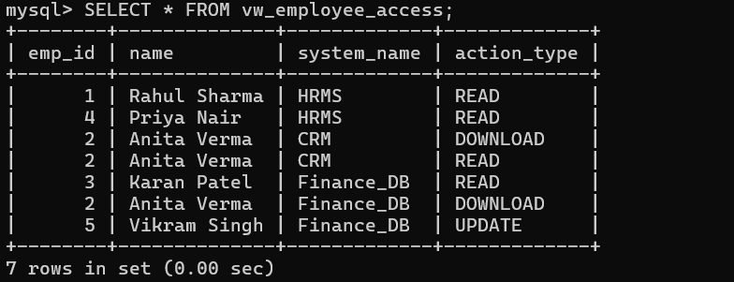

  - Writing complex queries based on the concepts of functions, Triggers, Cursors and Exception Handling

    - Complex queries based on Triggers
  - Question: Automatically convert employee name to uppercase before insert

SQL Statement:
DELIMITER $$

CREATE TRIGGER trg_uppercase_name
BEFORE INSERT ON employee
FOR EACH ROW
BEGIN
SET NEW.name = UPPER(NEW.name);
END$$

DELIMITER ;

INSERT INTO employee VALUES
(6, 'rohit mehta', 'rohit@company.com', 'Analyst', 'Finance');

SELECT emp_id, name FROM employee WHERE emp_id = 6;

Output:
Emp_id | Name
6 | ROHIT MEHTA
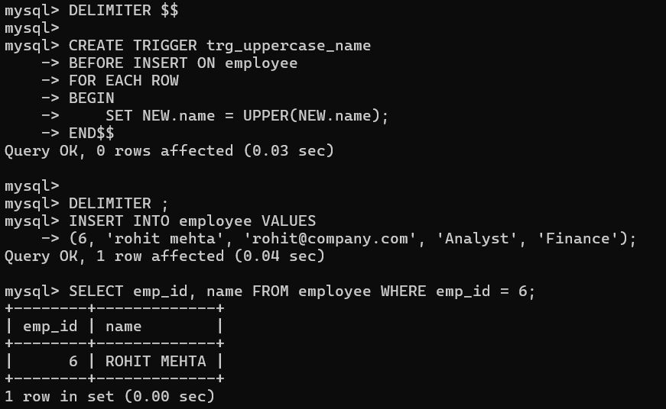

  - Question: Automatically set default action as 'READ' if not provided

SQL Statement:
DELIMITER $$
CREATE TRIGGER trg_default_action
BEFORE INSERT ON access_log
FOR EACH ROW
BEGIN
IF NEW.action_type IS NULL THEN
SET NEW.action_type = 'READ';
END IF;
END$$

DELIMITER ;

INSERT INTO access_log
(log_id, emp_id, system_id, asset_id, action_type, timestamp, ip_address, device_info)
VALUES (1009, 3, 103, 203, NULL, NOW(), '192.168.1.60', 'Desktop');

SELECT log_id, action_type FROM access_log WHERE log_id = 1009;

Output:
Log_id | Action_type
1009 | READ
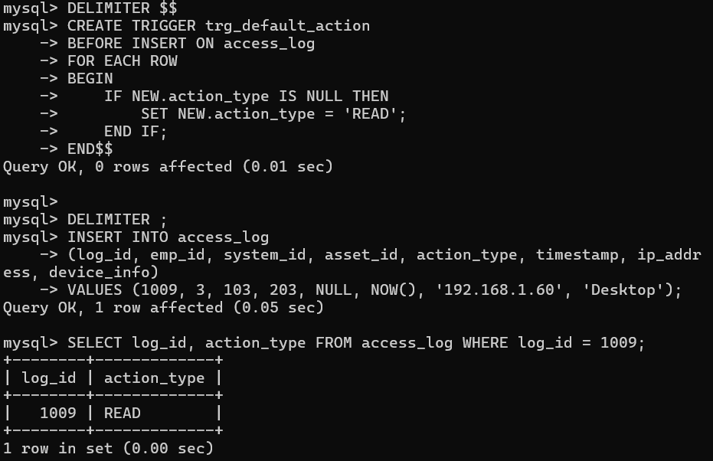

  - Question: Automatically update timestamp when access_log is inserted

SQL Statement:
DELIMITER $$

CREATE TRIGGER trg_update_timestamp
BEFORE INSERT ON access_log
FOR EACH ROW
BEGIN
SET NEW.timestamp = NOW();
END$$

DELIMITER ;

INSERT INTO access_log
VALUES (1010, 2, 102, 202, 'READ', NULL, '192.168.1.50', 'Laptop');

SELECT log_id, timestamp FROM access_log WHERE log_id = 1010;

Output:
Log_id | timestamp
1010 | 2026-03-19 20:31:09
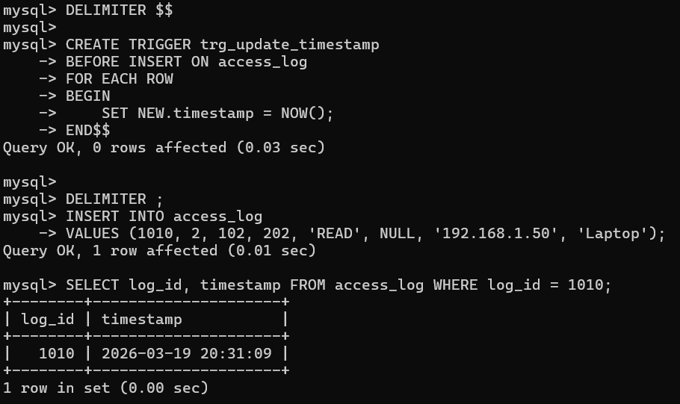

3.3.2 Complex queries based on Cursors
  - Question: Calculate total risk of all employees

SQL Statement:
DELIMITER $$

CREATE PROCEDURE sp_total_risk()
BEGIN
DECLARE done INT DEFAULT 0;
DECLARE r INT;
DECLARE total INT DEFAULT 0;

DECLARE cur CURSOR FOR SELECT risk_value FROM risk_score;
DECLARE CONTINUE HANDLER FOR NOT FOUND SET done = 1;

OPEN cur;

read_loop: LOOP
FETCH cur INTO r;
IF done THEN
LEAVE read_loop;
END IF;
SET total = total + r;
END LOOP;

CLOSE cur;

SELECT total AS total_risk;
END$$

DELIMITER ;

CALL sp_total_risk();

Output:
Total_risk
215
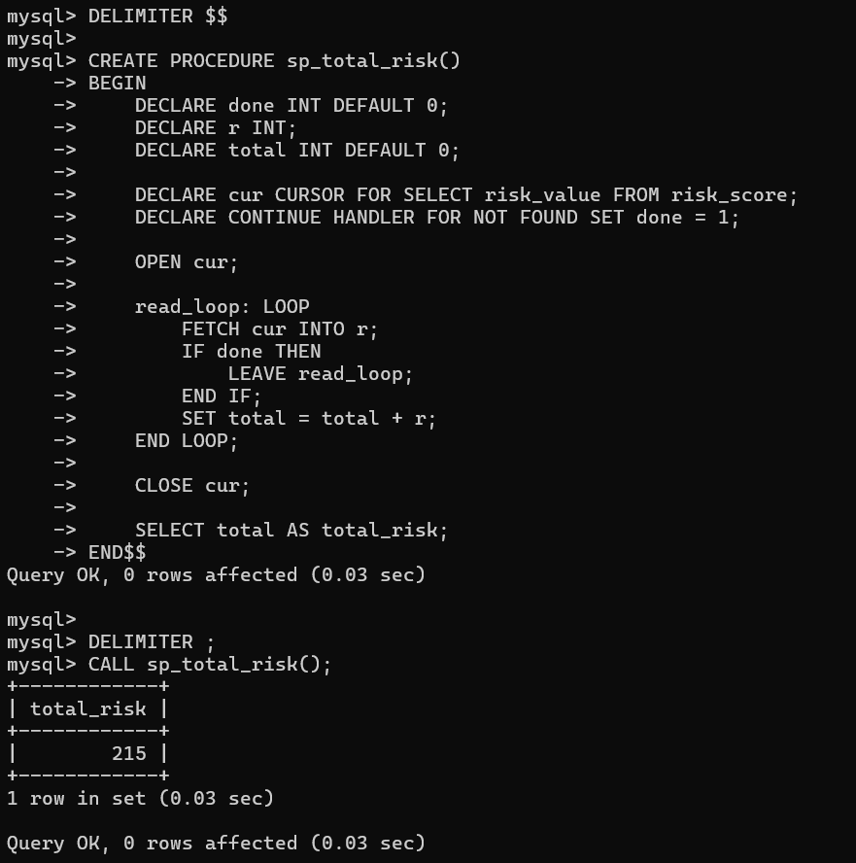

  - Question: Display employee names using cursor

SQL Statement:
DELIMITER $$

CREATE PROCEDURE sp_list_employees()
BEGIN
DECLARE done INT DEFAULT 0;
DECLARE emp_name VARCHAR(100);

DECLARE cur CURSOR FOR SELECT name FROM employee;
DECLARE CONTINUE HANDLER FOR NOT FOUND SET done = 1;

OPEN cur;

read_loop: LOOP
FETCH cur INTO emp_name;
IF done THEN
LEAVE read_loop;
END IF;
SELECT emp_name;
END LOOP;

CLOSE cur;
END$$

DELIMITER ;

CALL sp_list_employees();

Output:
Emp_name
Rahul Sharma

Emp_name
Anita Verma

Emp_name
Karan Patel

Emp_name
Priya Nair

Emp_name
Vikram Singh

Emp_name
ROHIT MEHTA
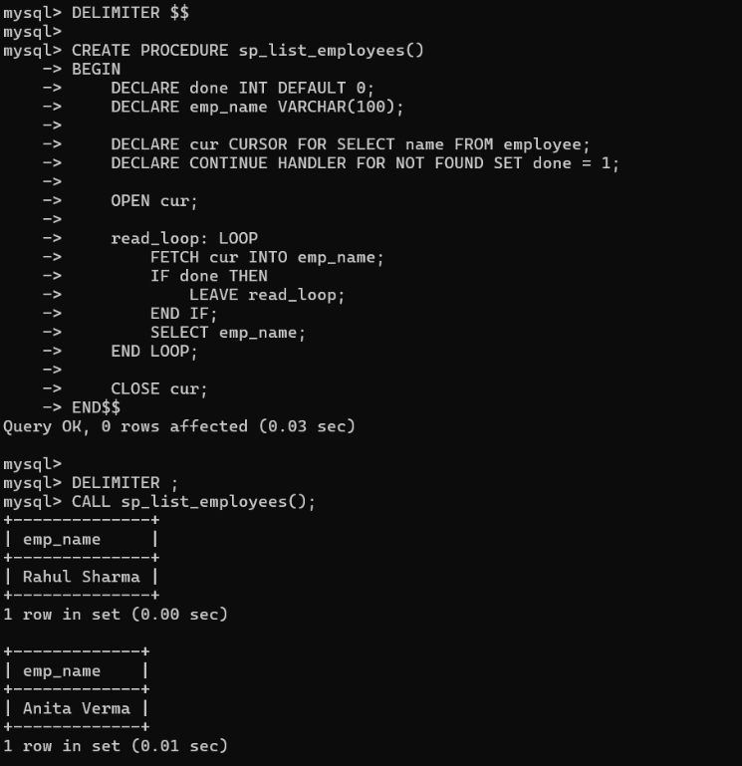
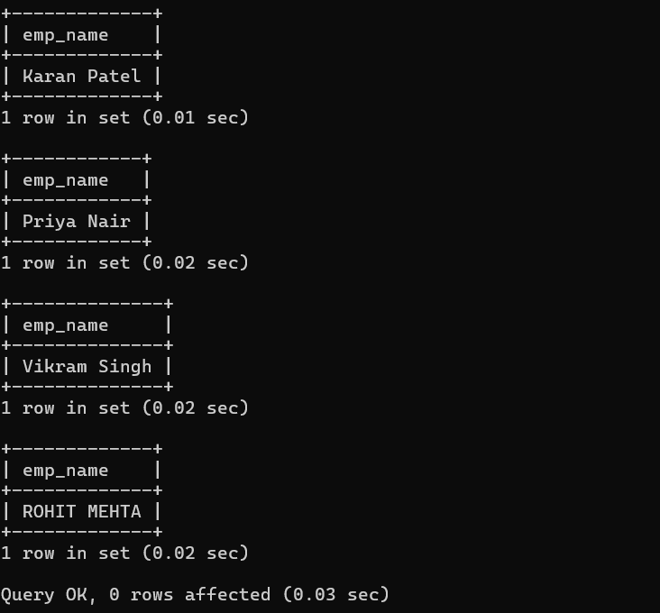
  - Question: Count employees department-wise using cursor

SQL Statement:
DELIMITER $$

CREATE PROCEDURE sp_count_by_dept()
BEGIN
DECLARE done INT DEFAULT 0;
DECLARE dept VARCHAR(50);

DECLARE cur CURSOR FOR SELECT DISTINCT department FROM employee;
DECLARE CONTINUE HANDLER FOR NOT FOUND SET done = 1;

OPEN cur;

read_loop: LOOP
FETCH cur INTO dept;
IF done THEN
LEAVE read_loop;
END IF;

SELECT dept, COUNT(*) AS total
FROM employee
WHERE department = dept;
END LOOP;

CLOSE cur;
END$$

DELIMITER ;

CALL sp_count_by_dept();

Output:
dept | Total
IT | 2

dept | Total
Security | 1

dept | Total
Finance | 2

dept | Total
HR | 1
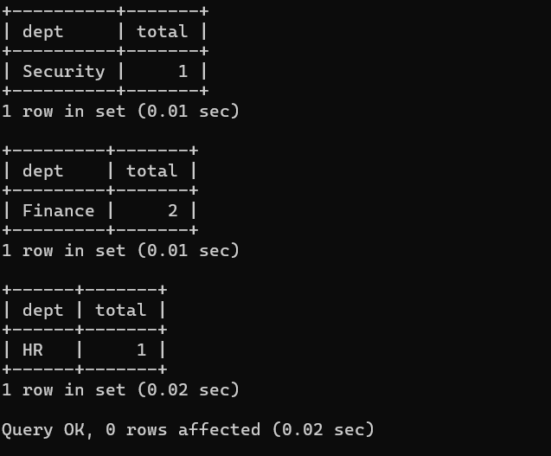
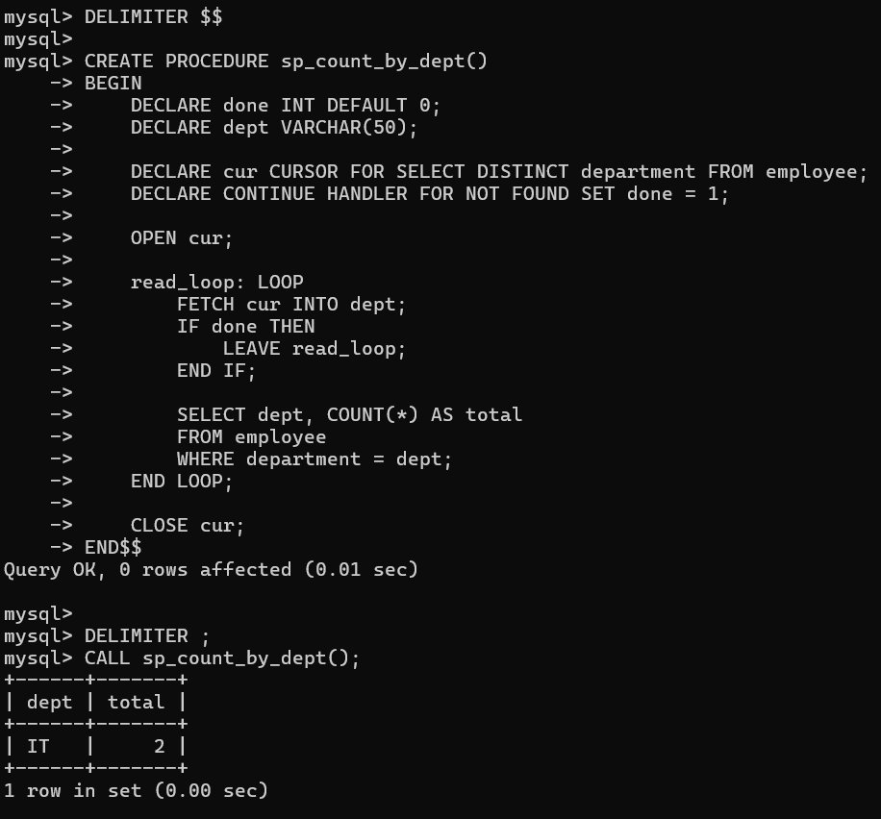

CHAPTER 4

ANALYZING THE PITFALLS, IDENTIFYING THE DEPENDENCIES, AND APPLYING NORMALIZATIONS

(show the table before and after respective normalization)

4.1 Analyse the Pitfalls in Relations
4.2 First Normal Form
4.2.1: Identify Dependency
4.2.2: Apply Normalization to 1NF

4.3 Second Normal Form
4.3.1: Identify Dependency
4.3.2: Apply Normalization to 2NF

4.4 Third Normal Form
4.4.1: Identify Dependency
4.4.2: Apply Normalization to 3NF

4.5 BCNF
4.5.1: Identify Dependency
4.5.2: Apply Normalization to BCNF

4.6 Fourth Normal Form
4.6.1: Identify Dependency
4.6.2: Apply Normalization to 4NF

4.7 Fifth Normal Form
4.7.1: Identify Dependency
4.7.2: Apply Normalization to 5NF

CHAPTER 5
IMPLEMENTATION OF CONCURRENCY CONTROL AND RECOVERY MECHANISMS

5.1 Introduction to Transactions
5.1.1 Properties
5.1.2 States
5.2 Transaction Control Language (TCL)
5.2.1 Save point
5.2.2 Commit
5.2.3 Rollback

5.3 create 5 transactions for your project and execute
5.3.1 Transaction1 code with output (min 5 transactions)
Use savepoints, commit, rollback
< Sample:
-- Step 1: Start transaction by updating book availability
UPDATE Books
SET available_copies = available_copies – 1 WHERE book_id = 101;

-- Step 2: Set a savepoint after first change
SAVEPOINT after_first_update;

-- Step 3: Another update
UPDATE Books SET available_copies = available_copies – 1 WHERE book_id = 102;

-- Step 4: Oops! Something's wrong with second update, rollback to savepoint
ROLLBACK TO after_first_update;

-- Step 5: Continue with a safe update
UPDATE Books SET available_copies = available_copies + 1 WHERE book_id = 101;

-- Step 6: Commit all changes since savepoint
COMMIT; >

Sample 2:
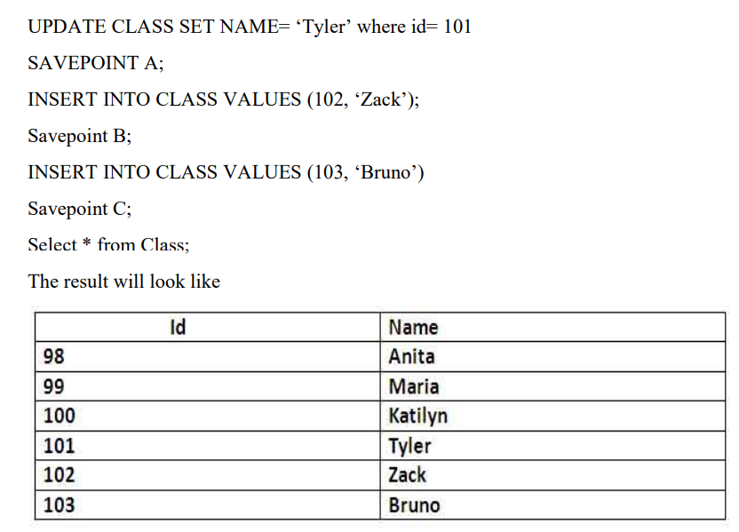
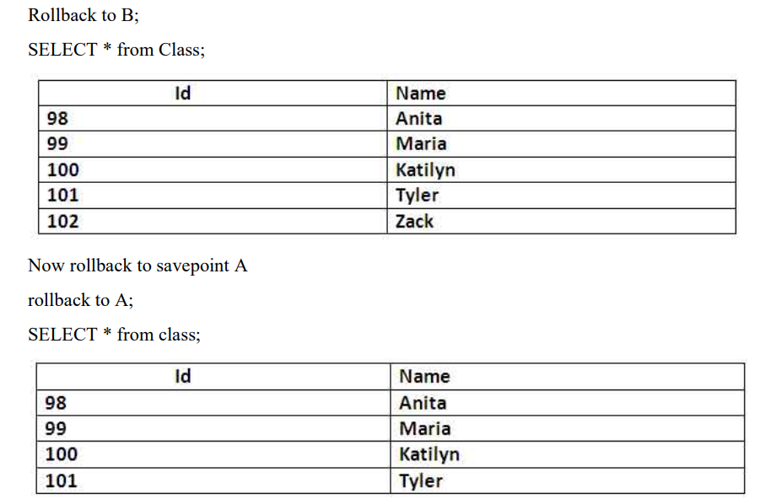

5.3 Concurrency control
5.3.1 Concurrency control Algorithms
5.3.1 Locking commands
a. Row-Level Locking – SELECT ... FOR UPDATE
b. Table-Level Locking – LOCK TABLE
Lock Modes
Lock Mode | Description
ROW SHARE | Allows concurrent access; prevents other sessions from locking the table exclusively.
ROW EXCLUSIVE | Prevents other sessions from locking in share mode. Used by default for DML.
SHARE | Allows queries but not updates or deletes.
SHARE ROW EXCLUSIVE | A mix; more restrictive than SHARE.
EXCLUSIVE | Prevents all other access — full table lock.

c. COMMIT – Release All Locks
d. ROLLBACK – Undo Changes & Release Locks
5.3.2 Example (1 example for your project)

CHAPTER 6
FRONT-END AND BACK-END CODE OF <PROJECT TITLE>

6.1 Front–End Module codes
6.2 Database connectivity

CHAPTER 7
RESULTS AND DISCUSSIONS

7.1 Screenshots of front-end

7.2 Screenshots of Database

References

